
Viewed by:
Philippe POHER
Tel.: +33 (0)2 99 27 92 92
E-mail: philippe.poher@iwedia.com

Written by:
Philippe POHER
Tel.: +33 (0)2 99 27 92 92
E-mail: philippe.poher@iwedia.com
IWEDIA

TBOX Technical Specifications

V2.1

Approved by:
Thierry GARNIER
Tel.: +33 (0)2 99 27 92 92
E-mail: thierry.garnier@iwedia.com

SUMMARY
1 Reference documents 4
2 Documentation History 5
3 Introduction 6
4 Module Overview and Architecture 7
4.1 Definitions, Acronyms and Abbreviations 7
4.2 General Description 8
4.2.1 Interactions with other TDAL modules 8
4.3 Architecture 8
4.4 TBOX API Description 9
4.4.1 Macros API 9
4.4.2 Functions used by Macros API 10
4.4.2.1 Mandatory functions 10
4.4.2.2 Optional functions used by comedia test application 11
5 TBOX API Specification 12
5.1 Type Specifications 12
5.2 TBOX API Usage 13
5.2.1 Module Traces Display Processings 13
5.3 TBOX Macro/Define/Enum/Typedef/Structure Definitions 14
5.3.1 MACRO Definitions 14
5.3.1.1 mTBOX_COMEDIA_FOR_INTEG_INIT 14
5.3.1.2 mTBOX_COMEDIA_FOR_INTEG_TRACE 14
5.3.1.3 mTBOX_TRACE_SYNCHRONE 14
5.3.1.4 mTBOX_SET_MODULE 14
5.3.1.5 mTBOX_FCT_ENTER 15
5.3.1.6 mTBOX_RETURN 15
5.3.1.7 mTBOX_COMEDIA_FOR_INTEG_INIT 16
5.3.1.8 mTBOX_INIT_MOD_TRACE 16
5.3.1.9 mTBOX_TRACE_ENABLED 16
5.3.1.10 mTBOX_TRACE_LOC_ENABLED 16
5.3.1.11 mTBOX_TRACE 17
5.3.1.12 mTBOX_PRINT 17
5.3.1.13 mTBOX_GETCHAR 17
5.3.1.14 mTBOX_GETCHAR 17
5.3.1.15 mTBOX_GETCHAR_NON_BLOCKING 17
5.3.1.16 mTBOX_GETSTRING_NON_BLOCKING 18
5.3.1.17 mTBOX_ASSERT 18
5.3.2 Define Definitions 18
5.3.2.1 TBOX_DEVHOST_FILE_ACCESS 18
5.3.2.2 kTBOX_TRC_BUFF_SIZE 18
5.3.2.3 kTBOX_SIT 18
5.3.2.4 kTBOX_TRC_XXX 18
5.3.2.5 TBOX_NIV 19
5.3.3 Enum Definitions 20
5.3.3.1 tTBOX_OpenMode 20
5.3.4 Typedef Definitions 20
5.3.4.1 tTBOX_TraceId 20
5.3.4.2 tTBOX_TraceMask 20
5.3.4.3 tTBOX_File 20
5.3.5 Structure Definitions 21
5.3.5.1 tTBOX_Time 21
5.4 TBOX API Functions 22
5.4.1 Generic Interface API 22
5.4.1.1 TBOX_SetTraceLocation(-) 22
5.4.1.2 TBOX_SetTraceTime(-) 23
5.4.1.3 TBOX_SetTraceEnabled(-) 24
5.4.1.4 TBOX_InitModuleTrace(-) 25
5.4.1.5 tTBOX_TraceId 25
5.4.1.6 TBOX_Trace(-) 26
5.4.1.7 TBOX_Print(-) 27
5.4.1.8 TBOX_GetChar(-) 28
5.4.1.9 TBOX_GetString(-) 29
5.4.1.10 TBOX_TraceSynchrone(-) 30
5.4.1.11 TBOX_GetCurrentTime(-) 31
5.4.1.12 TBOX_GetCharNonBlocking(-) 32
5.4.1.13 TBOX_GetStringNonBlocking(-) 33
5.4.1.14 TBOX_FileOpen(-) 34
5.4.1.15 TBOX_FileRead(-) 35
5.4.1.16 TBOX_FileClose(-) 36
5.4.1.17 TBOX_FileWrite(-) 37
5.4.1.18 TBOX_FileGetSize(-) 38
5.4.1.19 TBOX_FileSeek(-) 39
5.4.1.20 TBOX_FileTell(-) 40

Reference documents
The following documents were used to write this specification:

Document | Version | Title

Documentation History

History
Vers. | Date | Nature
1.0 | 09/01/2008 | Draft
2.0 | 11/01/2008 | Release
2.1 | 13/02/2008 | GS: Add TBOX_FileSeek() and TBOX_FileTell()

Introduction
The purpose of this document is to specify the interface and to describe the internal design of the Tool Box [TBOX] used for debug purpose. The aim of this module is to provide a complete interface between middlewares and low level of system environment for traces display either on serial port or JTAG interface.

Module Overview and Architecture

Definitions, Acronyms and Abbreviations
CHAL | Comedia hardware Adaptation Layer, composed of TDALs driver, TKEL and TBOX module
TDAL | Thin Driver Adaptation Layer
TKEL | Thin Kernel Encapsulation Layer
TBOX | Tool Box
OS | Operating System
RTOS | Real Time Operating System
ISR | Interrupt Service Routine
JTAG | Joint Test Action Group, interface for development tool

General Description
The main job of the TBOX API is to offer a generic interface for the comedia middleware for traces display in debug purpose.

Interactions with other TDAL modules
The TDAL modules may use TBOX API to display debug traces.

Architecture
The figure below shows the relation between the client module and the low level drivers:
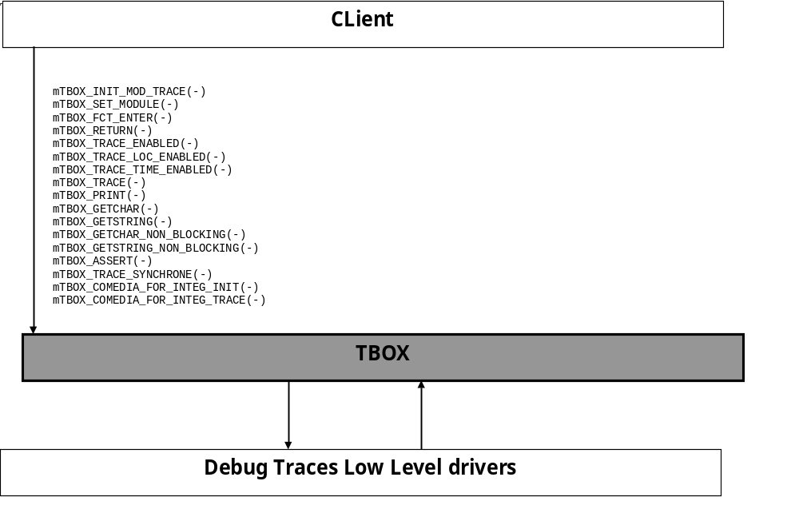

TBOX API Description

Macros API
The generic interface allows clients to control the TBOX module.
This interface is used with the following macros:
- mTBOX_INIT_MOD_TRACE in order to register a comedia module or tdal module to the TBOX system.
- mTBOX_SET_MODULE in order to declare a TBOX Id associated to a module
- mTBOX_FCT_ENTER in order to display a trace at the beginning of a function in a module
- mTBOX_RETURN in order to display a trace at the end of a function in a module
- mTBOX_TRACE_ENABLED in order to activate traces for registered module with a defined trace level.
- mTBOX_TRACE_LOC_ENABLED in order to display the line and file where the trace call is done.
- mTBOX_TRACE_TIME_ENABLED in order to display the time value of each trace
- mTBOX_TRACE in order to request display traces with trace level. The traces will be displayed or not according to the trace level set by mTBOX_TRACE_ENABLED.
- mTBOX_PRINT in order to display traces without trace level
- mTBOX_GETCHAR in order to get a char standard input. Such function is used in comedia unitary and integration test applications.
- mTBOX_GETSTRING in order to get a string on standard input. Such function is used in comedia unitary and integration test applications.
- mTBOX_GETCHAR_NON_BLOCKING in order to get a char on standard input and the standard output is not blocking. The client application may continue to display traces even if the end-user has no answer to the previous requests.
- mTBOX_GETSTRING_NON_BLOCKING in order to get a string on standard input and the standard output is not blocking. The client application may continue to display traces even if the end-user has no answer on standard input.
- mTBOX_ASSERT in order to process an assert call when fatal error is detected (Used really in development).
- mTBOX_TRACE_SYNCHRONE in order to render traces synchrone
- mTBOX_COMEDIA_FOR_INTEG_INIT in order to initialise the integration traces of the comedia middleware for a debug release with integration traces.
- mTBOX_COMEDIA_FOR_INTEG_TRACE in order to display integration traces of the comedia middleware for a debug release with integration traces.

Functions used by Macros API

Mandatory functions
TBOX_SetTraceLocation in order to display in which line and file the trace display is called.
TBOX_SetTraceTime in order to display the time value which each trace.
TBOX_SetTraceEnabled in order to enable traces display according to trace level for the module
TBOX_InitModuleTrace in order to register a module to TBOX system
TBOX_Trace in order to display traces with a defined trace level. If the level has been enabled by TBOX_SetTraceEnabled, the trace is displayed.
TBOX_Print in order to display a trace whatever the trace level has been set by TBOX_SetTraceEnabled.
TBOX_GetChar in order to get a char on standard input.
TBOX_GetString in order to get a string on standard input.
TBOX_TraceSynchrone in order to render the trace display synchrone with the client request. The traces will not be mixed.
TBOX_GetCurrentTime in order to get the current time from the start of the target.
TBOX_GetCharNonBlocking in order get a char on standard input without blocking the use of standard output for traces display.
TBOX_GetStringNonBlocking in order to get a straing on standard input without blocking the use of standard output for traces display.

Optional functions used by comedia test application
On some development environment, these functions enable to get data ,from distant computer by jtag interface, to process some tests:
TBOX_FileOpen in order to open a file on distant computer.
TBOX_FileRead in order to read a file on distant computer
TBOX_FileWrite in order to write a file on distant computer
TBOX_FileClose in order to close a file on distant computer
TBOX_FileGetSize in order to get a file size on distant computer
TBOX_FileSeek in order to seek in a file on distant computer.
TBOX_FileTell in order to get current position in a file on distant computer.

TBOX API Specification

Type Specifications
tTBOX_TraceId is the identifier of a module.
tTBOX_Time is a structure used to display traces time.
tTBOX_TraceMask is the level of the trace to display
tTBOX_File is a file handle of a TBOX File Stream.

TBOX API Usage

Module Traces Display Processings
The initialisation of TBOX API is made.
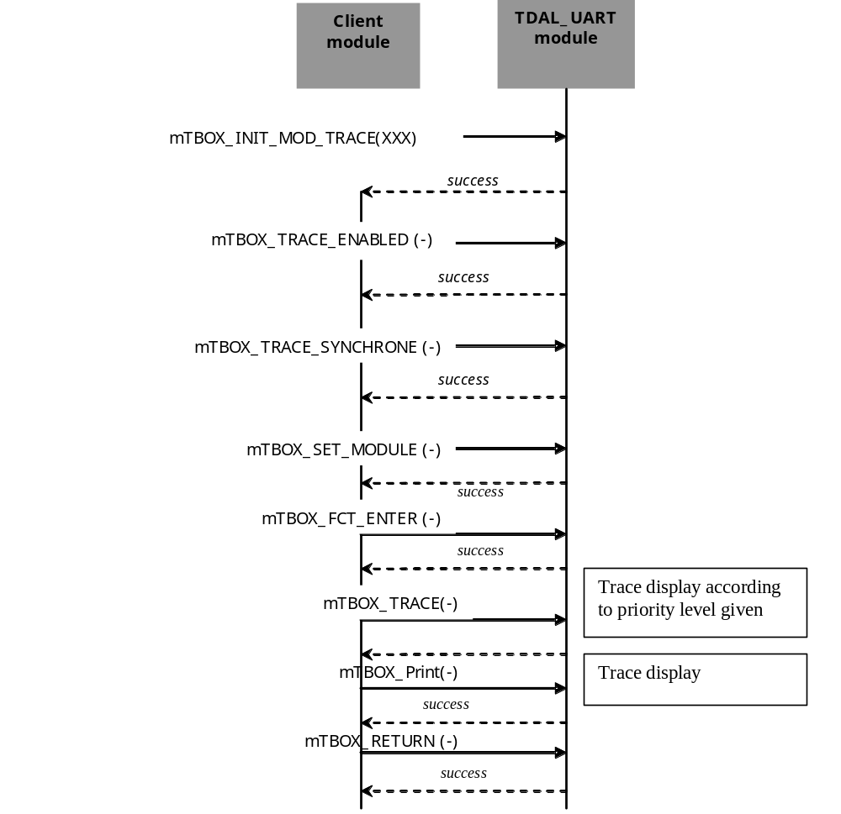

TBOX Macro/Define/Enum/Typedef/Structure Definitions

MACRO Definitions
The following macros are defined if __DEBUG_TRACE__ flag is set.

mTBOX_COMEDIA_FOR_INTEG_INIT
The following macro is defined with following value if COMEDIA_TRACES_FOR_INTEGRATION_ENABLE flag is set.
#define mTBOX_COMEDIA_FOR_INTEG_INIT TBOX_InitModuleTrace x

mTBOX_COMEDIA_FOR_INTEG_TRACE
The following macro is defined with following value if COMEDIA_TRACES_FOR_INTEGRATION_ENABLE flag is set.
#define mTBOX_COMEDIA_FOR_INTEG_TRACE TBOX_Trace x

mTBOX_TRACE_SYNCHRONE
The following macro is defined with following value if COMEDIA_TRACES_FOR_INTEGRATION_ENABLE flag or__DEBUG_TRACE__ flag is set.
#define mTBOX_TRACE_SYNCHRONE(x) TBOX_TraceSynchrone x

mTBOX_SET_MODULE
The following macro is defined with following value if __DEBUG_TRACE__ flag is set.
.
#define mTBOX_SET_MODULE(x) \
static char* TBOX_ModuleName = mTBOX_Str(x); \
static tTBOX_TraceId TBOX_ModuleID = x
#endif

mTBOX_FCT_ENTER
The following macro is defined with following value if __DEBUG_TRACE__ flag is set
If the flag __DEBUG_TIME__is set.
#define mTBOX_FCT_ENTER(x) \
char* TBOX_FunctionName = mTBOX_Str(x); \
struct timeb TBOX_TopBeg, TBOX_TopEnd; \
double TBOX_duration; \
ftime(&TBOX_TopBeg); \
mTBOX_TRACE((kTBOX_NIV_FCT, "{ %s :\n", TBOX_FunctionName))
else
#define mTBOX_FCT_ENTER(x) \
char* TBOX_FunctionName = mTBOX_Str(x); \
mTBOX_TRACE((kTBOX_NIV_FCT, "{ %s :\n", TBOX_FunctionName))

mTBOX_RETURN
The following macro is defined with following value if __DEBUG_TRACE__ flag is set.
If the flag __DEBUG_TIME__is set.

#define mTBOX_RETURN \
ftime(&TBOX_TopEnd); \
TBOX_duration = (((double)TBOX_TopEnd.time - (double)TBOX_TopBeg.time)*1000.0 + (double)TBOX_TopEnd.millitm - (double)TBOX_TopBeg.millitm)/1000.0;\
if (TBOX_duration > 0.109) { \
mTBOX_TRACE((kTBOX_NIV_CRITICAL,"} %s (%.03f sec)\n",TBOX_FunctionName,TBOX_duration));\
} \
else { \
mTBOX_TRACE((kTBOX_NIV_FCT,"} %s (%.03f sec)\n",TBOX_FunctionName,TBOX_duration));\
} \
return
else
#define mTBOX_RETURN \
mTBOX_TRACE((kTBOX_NIV_FCT, "} %s\n", TBOX_FunctionName)); \
return

mTBOX_COMEDIA_FOR_INTEG_INIT
The following macro is defined with following value if __DEBUG_TRACE__ and __DEBUG_TIME__
flag are set.
#define mTBOX_RETURN \
ftime(&TBOX_TopEnd); \
TBOX_duration = (((double)TBOX_TopEnd.time - (double)TBOX_TopBeg.time)*1000.0 + (double)TBOX_TopEnd.millitm - (double)TBOX_TopBeg.millitm)/1000.0;\
if (TBOX_duration > 0.109) { \
mTBOX_TRACE((kTBOX_NIV_CRITICAL,"} %s (%.03f sec)\n",TBOX_FunctionName,TBOX_duration));\
} \
else { \
mTBOX_TRACE((kTBOX_NIV_FCT,"} %s (%.03f sec)\n",TBOX_FunctionName,TBOX_duration));\
} \
return

mTBOX_INIT_MOD_TRACE
The following macro is defined with following value if __DEBUG_TRACE__ flag is set.
#define mTBOX_INIT_MOD_TRACE(x) TBOX_InitModuleTrace x

mTBOX_TRACE_ENABLED
The following macro is defined with following value if COMEDIA_TRACES_FOR_INTEGRATION_ENABLE flag or__DEBUG_TRACE__ flag is set.
#define mTBOX_TRACE_ENABLED(x) TBOX_SetTraceEnabled x

mTBOX_TRACE_LOC_ENABLED
The following macro is defined with following value if __DEBUG_TRACE__ flag is set.
If the flag __DEBUG_TIME__is set.
#define mTBOX_TRACE_LOC_ENABLED(x) TBOX_SetTraceLocation x

mTBOX_TRACE
The following macro is defined with following value if __DEBUG_TRACE__ flag is set.

#define mTBOX_TRACE(x) TBOX_Trace x

mTBOX_PRINT
The following macro is defined with following value if __DEBUG_TRACE__ flag is set.

#define mTBOX_PRINT(x) TBOX_Print x

mTBOX_GETCHAR
The following macro is defined with following value if __DEBUG_TRACE__ flag is set.

#define mTBOX_GETCHAR(x) TBOX_GetChar x

mTBOX_GETCHAR
The following macro is defined with following value if __DEBUG_TRACE__ flag is set.

#define mTBOX_GETSTRING(x) TBOX_GetString x

mTBOX_GETCHAR_NON_BLOCKING
The following macro is defined with following value if __DEBUG_TRACE__ flag is set.

#define mTBOX_GETCHAR_NON_BLOCKING(x) TBOX_GetCharNonBlocking x

mTBOX_GETSTRING_NON_BLOCKING
The following macro is defined with following value if __DEBUG_TRACE__ flag is set.

#define mTBOX_GETSTRING_NON_BLOCKING(x) TBOX_GetStringNonBlocking x

mTBOX_ASSERT
The following macro is defined with following value if __DEBUG_TRACE__ flag is set.

#define mTBOX_ASSERT(x) if(!(x)) mTBOX_PRINT((kTBOX_LF,"Assertion failed in FILE %s, LINE %d\n", __FILE__, __LINE__))

Define Definitions

TBOX_DEVHOST_FILE_ACCESS
This constant is used to enable or not the file access function of TBOX module.
#define TBOX_DEVHOST_FILE_ACCESS 1

kTBOX_TRC_BUFF_SIZE
This constant is used to define the maximum size of string which must be displayed by TBOX
#define kTBOX_TRC_Buff_Size 1024

kTBOX_SIT
This constant is used in KTBOX_NIV
#define kTBOX_SIT __LINE__,__FILE__,TBOX_ModuleID,TBOX_ModuleName

kTBOX_TRC_XXX
These constants are used by the client to set the level traces filter with the call of mTBOX_TRACE_ENABLED macro.
#define kTBOX_TRC_NONE 0x00 /* No trace */
#define kTBOX_TRC_CRITICAL 0x01 /* Critical error which need to reboot */
#define kTBOX_TRC_WARNING 0x02 /* Minor error */
#define kTBOX_TRC_FCT 0x04 /* Functions enter and exit */
#define kTBOX_TRC_1 0x08 /* Trace level 1 */
#define kTBOX_TRC_2 0x10 /* Trace level 2 */
#define kTBOX_TRC_3 0x20 /* Trace level 3 */
#define kTBOX_TRC_4 0x40 /* Trace level 4 */
#define kTBOX_TRC_5 0x80 /* Trace level 5 */
#define kTBOX_TRC_ALL 0xFF /* All levels */

TBOX_NIV
These constants are used by the client to display trace according to a trace level with the call of mTBOX_TRACE macro.
/* Defines for TBOX_TRACE calls */
#define kTBOX_NIV_CRITICAL kTBOX_SIT,kTBOX_TRC_CRITICAL /* Critical error which need to reboot */
#define kTBOX_NIV_WARNING kTBOX_SIT,kTBOX_TRC_WARNING /* Minor error */
#define kTBOX_NIV_FCT kTBOX_SIT,kTBOX_TRC_FCT /* Functions enter and exit */
#define kTBOX_NIV_1 kTBOX_SIT,kTBOX_TRC_1 /* Trace level 1 */
#define kTBOX_NIV_2 kTBOX_SIT,kTBOX_TRC_2 /* Trace level 2 */
#define kTBOX_NIV_3 kTBOX_SIT,kTBOX_TRC_3 /* Trace level 3 */
#define kTBOX_NIV_4 kTBOX_SIT,kTBOX_TRC_4 /* Trace level 4 */
#define kTBOX_NIV_5 kTBOX_SIT,kTBOX_TRC_5 /* Trace level 5 */

Enum Definitions

tTBOX_OpenMode
An enumeration of the different possible opening file mode only if this option is supported by the environment.
typedef enum {
eTBOX_READ,
eTBOX_WRITE
} tTBOX_OpenMode;

Typedef Definitions

tTBOX_TraceId
The definition of the trace mask to set the trace identifier of a client module
typedef unsigned long tTBOX_TraceId;

tTBOX_TraceMask
The definition of the trace mask to set the trace level to display traces required by client module.
typedef unsigned char tTBOX_TraceMask;

tTBOX_File
The definition of the file handle when file acces on distant computer is supported by the environment
typedef uint32_t tTBOX_File;

Structure Definitions

tTBOX_Time
Description:
This structure is used to define the time values returns by TBOX system
Definition:
typedef struct{
unsigned long sec;
unsigned long min;
unsigned long hour;
unsigned long msec;
}tTBOX_Time;
Elements:
Field | Type | Description
Sec | unsigned long | Secondes
min | unsigned long | Minutes
hour | unsigned long | Hours
msec | unsigned long | millisecondes
Comments:

See Also:

TBOX API Functions

Generic Interface API

TBOX_SetTraceLocation(-)
Prototype:
void TBOX_SetTraceLocation(bool enable_trace);
Description:
This function enables or disables the trace location display.
Return value:
None
Parameters:
Parameter | Type | Dir | Description
enable_trace | bool | In | True: location display is done.
Comments:

See Also:

TBOX_SetTraceTime(-)
Prototype:
void TBOX_SetTraceTime(bool enable_trace);
Description:
This function enables or disables the trace time display.
Return value:
None.

Parameters:
Parameter | Type | Dir | Description
enable_trace | bool | In | True: time display is done.

Comments:
None
See Also:

TBOX_SetTraceEnabled(-)
Prototype:
void TBOX_SetTraceEnabled(bool trace_enable_value);
Description:
This function enables traces display

Return value:
None
Parameters:
Parameter | Type | Dir | Description
trace_enable_value | bool | In | True: traces are displayed.

Comments:

See Also:

TBOX_InitModuleTrace(-)
Prototype:
void TBOX_InitModuleTrace(tTBOX_TraceId mod_id, tTBOX_TraceMask mask_init);
Description:
This function registers for a module identified by TRACE_Id the trace level to display.
Return value:

Parameters:
Parameter | Type | Dir | Description
mod_id | tTBOX_TraceId | In | Module identification
mask_init | tTBOX_TraceMask | In | Trace level to display for the module
Comments:
See Also:
tTBOX_TraceId
tTBOX_TraceId

TBOX_Trace(-)
Prototype:
void TBOX_Trace
(int line,
char *file,
tTBOX_TraceId mod_id,
char *modName,
tTBOX_TraceMask trc_level,
char *fmt,
...);
Description:
This function enables to a client to requires a display trace with trace level.
Return value:

Parameters:
Parameter | Type | Dir | Description
line | int | In | Line in the file
file | char * | In | File Name
mod_id | tTBOX_TraceId | In | Identifier of the trace
modName | char * | In | Module name
trc_level | tTBOX_TraceMask | In | Trace level
Fmt, ** | char * | In | String and argument to display
Comments:

See Also:
tTBOX_TraceId
tTBOX_TraceMask

TBOX_Print(-)
Prototype:
void TBOX_Print(int line,char *file,char *fmt, ...);
Description:
This function enables to force a permanent display trace.
Return value:

Parameters:
Parameter | Type | Dir | Description
instance | tTDAL_UART_Instance | In | In: instance to read
pBytesRead | uint8_t* | In/Out | In: buffer allocated by the client  Out: Buffer filled with data in buffer of UART if they exist
nbBytesToRead | uint32_t | In | Max length to read (maximum size of pBytesRead)
pNbBytesRead | uint32_t* | Out | Real Amount of data read on instance

Comments:

See Also:

TBOX_GetChar(-)
Prototype:
void TBOX_GetChar( char * c )
Description:
This function enables the client to wait and get char on standard input.
The standard output is blocked during this call.
Return value:

Parameters:
Parameter | Type | Dir | Description
c | Char * | Out | Bytes enter by end-user on prompt
Comments:

See Also:

TBOX_GetString(-)
Prototype:
void TBOX_GetString(char* string);
Description:
This function enables the client to wait and get a string on standard input. The standard output is blocked during the call.
Return value:

Parameters:
Parameter | Type | Dir | Description
string | Char * | Out | String read in prompt
Comments:

See Also:

TBOX_TraceSynchrone(-)
Prototype:
void TBOX_TraceSynchrone(bool bTraceSync);
Description:
This function enables the client to require that traces are synchrones. All traces of all clients done at the same time are not mixed on the standard output.
Return value:

Parameters:
Parameter | Type | Dir | Description
bTraceSync | bool | In | True: Protection by mutex on display for each client trace

Comments:

See Also:

TBOX_GetCurrentTime(-)
Prototype:
void TBOX_GetCurrentTime(tTBOX_Time* TboxCurrentTime);
Description:
This function enables the client to get the current time from the boot of the target.
Return value:

Parameters:
Parameter | Type | Dir | Description
TboxCurrentTime | tTBOX_Time * | Out | Time from the boot of the target

Comments:

See Also:

TBOX_GetCharNonBlocking(-)
Prototype:
void TBOX_GetCharNonBlocking(char *c);
Description:
This function enables the client to get a char on standard input without blocking the standard output display.
Return value:

Parameters:
Parameter | Type | Dir | Description
C | char * | Out | The char got

Comments:

See Also:

TBOX_GetStringNonBlocking(-)
Prototype:
void TBOX_GetStringNonBlocking( char * string );
Description:
This function enables the client to get a string on standard input without blocking the standard output display.
Return value:

Parameters:
Parameter | Type | Dir | Description
string | char * | Out | The string got

Comments:

See Also:

TBOX_FileOpen(-)
Prototype:
tTBOX_File TBOX_FileOpen(char * filename, tTBOX_OpenMode mode);
Description:
This function enables the client to get file on distant computer by JTAG if the environment enables such action.
Return value:

Parameters:
Parameter | Type | Dir | Description
filename | char * | In | The filename of file to open
mode | tTBOX_OpenMode | In | Mode of opening (R/W)

Comments:

See Also:

TBOX_FileRead(-)
Prototype:
unsigned long TBOX_FileRead
(tTBOX_File file ,
void * buffer ,
unsigned long buffer_size );
Description:
This function enables the client to read file opened on distant computer by JTAG if the environment enables such action.
Return value:

Parameters:
Parameter | Type | Dir | Description
file | tTBOX_File | In | The file handle
buffer | void * | Out | Buffer with file data
buffer_size | Unsigned long | In | Data to read

Comments:

See Also:

TBOX_FileClose(-)
Prototype:
void TBOX_FileClose( tTBOX_File file );
Description:
This function enables the client to close file stream opened on distant computer by JTAG if the environment enables such action.
Return value:

Parameters:
Parameter | Type | Dir | Description
file | tTBOX_File | In | The file handle

Comments:

See Also:

TBOX_FileWrite(-)
Prototype:
unsigned long TBOX_FileWrite
(tTBOX_File file ,
void * buffer ,
unsigned long buffer_size );
Description:
This function enables the client to write file opened on distant computer by JTAG if the environment enables such action.
Return value:

Parameters:
Parameter | Type | Dir | Description
file | tTBOX_File | In | The file handle
buffer | void * | In | Buffer with file data
buffer_size | Unsigned long | In | Size of buffer to write

Comments:

See Also:

TBOX_FileGetSize(-)
Prototype:
unsigned long TBOX_FileGetSize( tTBOX_File file );
Description:
This function enables the client to the file size of the opened file on distant computer by JTAG if the environment enables such action.
Return value:

Parameters:
Parameter | Type | Dir | Description
file | tTBOX_File | In | The file handle

Comments:

See Also:

TBOX_FileSeek(-)
Prototype:
unsigned long TBOX_FileSeek(tTBOX_File file, long offset, int whence);
Description:
This function sets the position indicator associated with the file handle to a new position defined by adding offset to a reference position specified by whence.
This function allows the client to seek in the opened file on distant computer by JTAG if the environment enables such action.
Return value:
Upon successful completion, the resulting offset, as measured in bytes from the beginning of the file, is returned.
Otherwise, (-1) is returned, the file offset remains unchanged.
Parameters:
Parameter | Type | Dir | Description
file | tTBOX_File | In | The file handle
long | offset | In | Number of bytes to offset from “whence”
int | whence | In | Position from where offset is added. If whence is set to 0 (set), 1 (current), or 2 (end), the offset is relative to the start of the file, the current position indicator, or end-of-file, respectively.

Comments:

See Also:

TBOX_FileTell(-)
Prototype:
unsigned long TBOX_FileTell(tTBOX_File file);
Description:
This function obtains the current value of the file position indicator for an opened file on distant computer by JTAG if the environment enables such action.
Return value:
Upon successful completion, it returns the current offset. Otherwise, (-1) is returned.
Parameters:
Parameter | Type | Dir | Description
file | tTBOX_File | In | The file handle

Comments:

See Also:

